
LAB REPORT
ENGE 241_Analog Circuit Lab (Put the course name here)
Lab_05. Superposition (Put the lab title here)

Isaac Newton (Put your name here)

Overview
Briefly explain the experiments you implemented during the lab.

Background
Briefly explain the theories you applied in the lab.

Observations/Experimental Results
List all experiment results, including measurements, truth tables, waveforms, and snapshots. Please number every result and add your explanation following each of them. Without proper explanation, results posted here won’t be taken into account in grading.
Example:
- Truth Table of J-K Flip-Flop

Explanation: Table I listed the observed truth table of the J-K Flip-Flop. According to its logic function: …
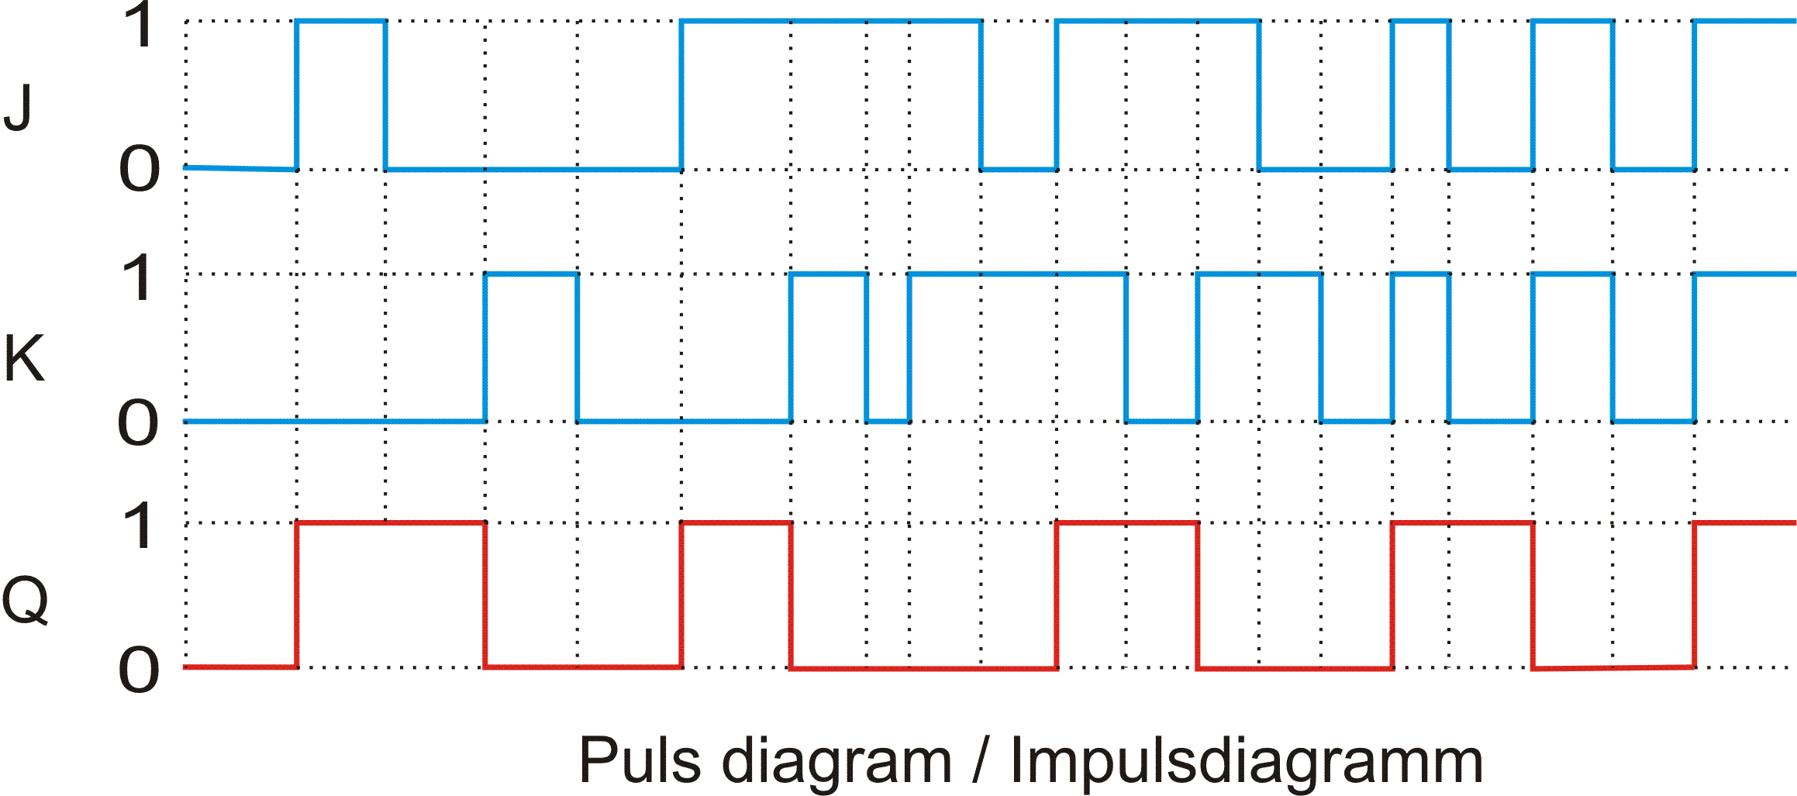
- Most used WECS configuration [1]
Figure 1 shows the timing diagram of a J-K flip-flop. According to …
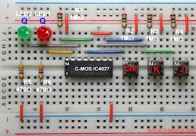
- Most used WECS configuration [2]
Figure 2 shows the J-K flip-flop circuit. It is constructed by …

Discussion of Results and Conclusion
Please briefly state your conclusion of the lab and what you have learned from the lab. Include answers of question asked in the lab manual, if any.

(Optional) Comments
If you have any comment please put here.

Signature: ___________________________ Submission Date: ___________________________

Please be noticed:
- Everyone shall work on and submit an individual lab report. Team-working is recommend in doing labs but not in writing reports. And please specify your contribution in each lab.
- You can enhance your report by citing any picture, text and even multimedia contents in your report as long as no violation with copy right. But please remember to give the creator credits by adding citations, as shown below.

References
- http://commons.wikimedia.org/wiki/File:JK_FF_async_PD.gif
- http://en.f-alpha.net/electronics/digital-electronics/flip-flops/lets-go/experiment-10-jk-flip-flop.html
- Bowman, M., Debray, S. K., and Peterson, L. L. 1993. Reasoning about naming systems. ACM Trans. Program. Lang. Syst. 15, 5 (Nov. 1993), 795-825. DOI= http://doi.acm.org/10.1145/161468.16147.
- Ding, W. and Marchionini, G. 1997. A Study on Video Browsing Strategies. Technical Report. University of Maryland at College Park.
- Fröhlich, B. and Plate, J. 2000. The cubic mouse: a new device for three-dimensional input. In Proceedings of the SIGCHI Conference on Human Factors in Computing Systems (The Hague, The Netherlands, April 01 - 06, 2000). CHI '00. ACM, New York, NY, 526-531. DOI= http://doi.acm.org/10.1145/332040.332491.
- Tavel, P. 2007. Modeling and Simulation Design. AK Peters Ltd., Natick, MA.
- Sannella, M. J. 1994. Constraint Satisfaction and Debugging for Interactive User Interfaces. Doctoral Thesis. UMI Order Number: UMI Order No. GAX95-09398., University of Washington.

